Project Design Phase
Solution Architecture

Date | 7 march 2025
Team ID
Project Name | Visualization Tool for Electric Vehicle Charge and Range Analysis
Maximum Marks | 4 Marks

Solution Architecture: EV Analytics Dashboard
The EV Analytics Dashboard bridges the gap between fragmented EV data and actionable insights for buyers, policymakers, and manufacturers. It follows a structured architecture that ensures scalability, clarity, and effective decision-making support.

Goals:
- Identify the best tech stack to visualize EV specifications and infrastructure data.
- Present a clear structure and behavior of the solution to stakeholders (EV buyers, analysts, policymakers).
- Define key features such as model comparison, charging station mapping, range– price filtering, and segment-level insights.
- Establish specifications and calculated fields to standardize data cleaning, integration, and visual delivery.

Example - Solution Architecture Diagram:

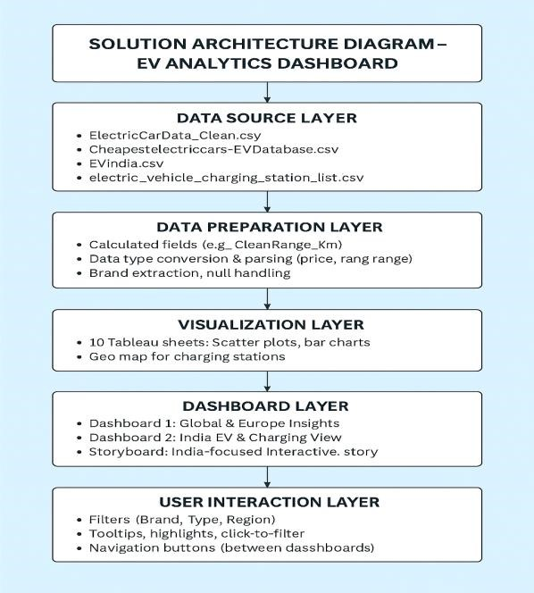
Figure 1: Solution Architecture Diagram – EV Analytics Dashboard

